**ADDING A SCRIPT TO THE TRAVELPORT GALILEO DESKTOP TOOLBAR**

1. Open Galileo Desktop
2. Go to Options – Viewpoint Custom Toolbar Editor (Or click on **Terminal** to access *ViewPoint*). In the menu bar you will find **Options**.

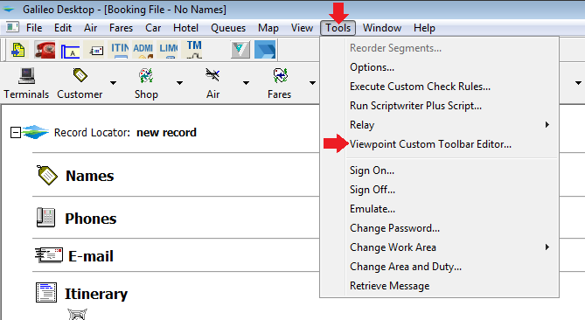

1. Scroll down to **Viewpoint Custom Toolbar Editor**. Click on it

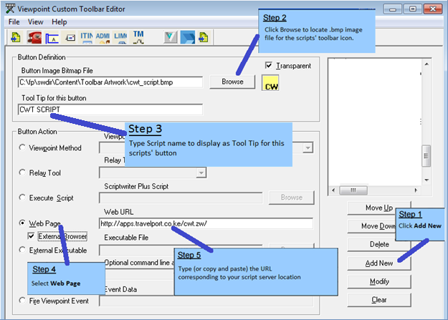

1. Close the Editor and when prompted Save the changes.
2. Re-start Galileo Desktop for the changes to take effect.